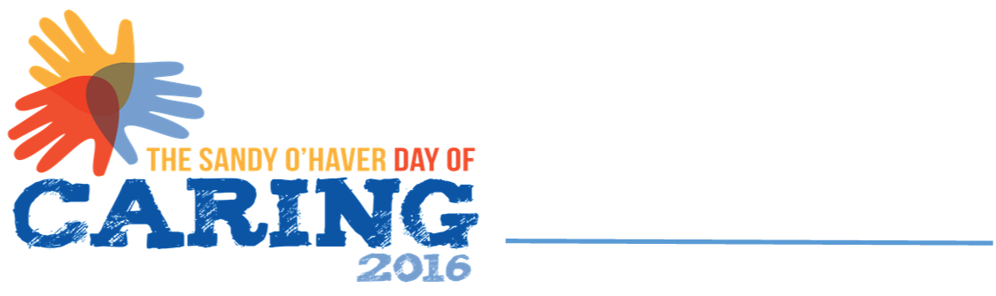

**VOLUNTEER CONSENT AND RELEASE**

I hereby release the United Way of the Upper Ohio Valley and its member agencies from any liability for any accident or injury that may occur while I am volunteering as part of the **DAY OF CARING** program on September 11th, 2024.

In addition, I authorize United Way of the Upper Ohio Valley and its affiliates to take and use photographs, audio, video, radio, or television tape or film of me for purposes of publicizing **DAY OF CARING** activities.

**______________________________________________________________________________**

Name *(Print Clearly)*

*_________________________________________________________________*_____

Home Address

______________________________________________________________________

City, State Zip

**______________________________________________________________________________**

Signature Date

______________________________________________________________________

Email

United Way of the Upper Ohio Valley • 1307 Chapline St. • Wheeling, WV 26003-2903

(304) 232-4625 • FAX (304) 232-3370