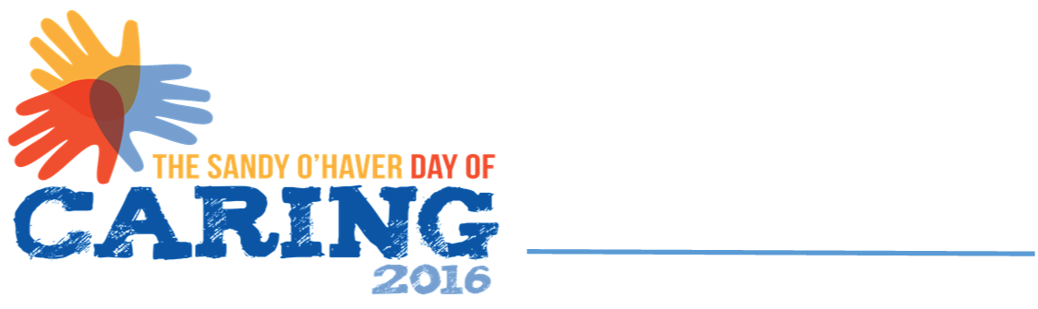

VOLUNTEER RECRUITMENT FORM

To sign up volunteers for DAY OF CARING, please list the names of those volunteering, indicating one person as a contact. If possible, your group will be assigned to one agency. The contact person named will be contacted regarding details about the agency and the volunteer activity assigned. Volunteer assignments will be made on a "first come, first served" basis. Agencies provide lunch for volunteers. All volunteers should wear old clothes.

Please RSVP by August 18, 2020. Registration may be emailed to mtaylor@unitedwayuov.org, mailed to United Way of the Upper Ohio Valley, 1307 Chapline Street, Wheeling WV 26003-2903 or FAX to (304) 232-3370.

CONTACT NAME ____________________________________________________________

ORGANIZATION ____________________________________________________________

ADDRESS ____________________________________________________________

CITY/STATE/ZIP ____________________________________________________________

TELEPHONE___________________ FAX________________________

E-MAIL _______________________________________________

Confirmation will be sent to contact person listed above. Please list names of individuals in group below and list T-shirt size (S, M, L, 1X, 2X, 3X).

VOLUNTEERS

NAME ________________________ T.SZ____ NAME_______________________ T.SZ____

NAME ________________________ T.SZ____ NAME_______________________ T.SZ____

NAME ________________________ T.SZ____ NAME_______________________ T.SZ____

NAME ________________________ T.SZ____ NAME_______________________ T.SZ____

NAME ________________________ T.SZ____ NAME_______________________ T.SZ____

