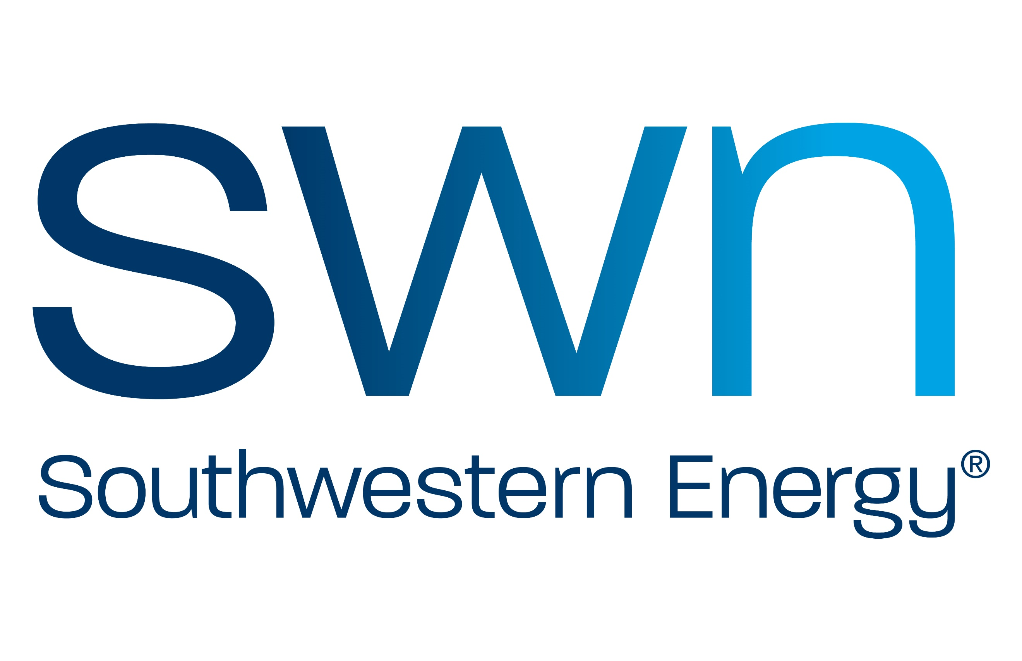

SWN Food Insecurity Grant
The United Way of the Upper Ohio Valley is partnering with SWN to provide funding for organizations who are meeting food insecurity needs in their communities.
Funding range: up to $2500
- Nonprofit organizations are encouraged to submit applications as soon as possible.
- Application process will conclude February 5th.
- Please email your completed application to jrine@unitedwayuov.org.
- Applications will not be accepted via mail.
Funding priorities include, but are not limited to:
- Food insecurities programs
- Food pantries/shelters
- Backpack programs
- After school programs
- Senior programs

Guidelines:
We may receive a high volume of requests for these funds so applicants are advised that we do not expect to be able to cover all funding requests or fund the full amount of each request. We are committed to making the best use of available resources to address the highest priority needs.
Applicants are limited to nonprofits and organizations that are:
- Located in Brooke, Ohio, Marshall and Wetzel Counties in West Virginia
- Providing services to residents of Brooke, Ohio, Marshall and Wetzel Counties in West Virginia
- Registered as a charitable organization or program.

Application for SWN Insecurities Grant Funding

SECTION 1
Organization Name Requested Amount $

Contact Person Title

Contact Number Email

Address EIN#

City State Zip

Program Name:

Target Population: (including county served)

Expected Outcomes: (What goal you hope to reach, number of people served, etc.)

Brief description of requested programs:

Is this a new program in direct response to the pandemic?

Are you collaborating with any other agencies on these efforts?

Will this grant fully fund this program’s needs?

